Content

1. Introduction
2. Problem Description
3. Mission and Vision
4. Database Design
5. Form Design
6. How to use system
7. Technology
8. Introduction
9. Planning
10. Analysis
11. Design
12. Implementation
13. Support and Testing

1. Problem Description

Decision support systems are all about helping managers making a decision that is heavily supported by the data collected, past experiences, etc. Often, decision support systems are based on more than one database. This allows for integration of more data, and it results in a better decision-making process. Integrating different databases, however, is not an easy task. For example, although very critical, there are cases where the databases at clinics and insurance companies are not integrated. This lack of integration has a twofold effect: (a) insurance companies find it difficult to design or negotiate health care programs; and (b) practitioners are unable to take advantage of or participate in designing insurance programs.

1. Mission and Vision

* The aim of this project is to design a decision support system that will integrate the data stored in different insurance companies and health care providers.
* The objective is to provide supporting information to the participants to make the right decision about insurance programs.

1. Database Design

Doctor

Patient

HealthCare Provider

Insurance Company

Disease

Is cured by

has

Work for

Cooperate

Visit

Has

Transaction

Premium

M

1

M

1

1

1

M

1

M

1

M

1

M

1

M

1

1

1

M

1

1

M

1

M

M

1

1

1

1

M

M

Healthcare Plan

1

M

1

1

1

1

1

Table:

1. Form Design
2. Login and Registration
3. Login

* Username
* Password

1. Registration

* First name
* Last name
* Username
* Password

1. Data Entry

* Insurance
* Provider
* Patient
* Doctor
* Disease
* Transaction
* Premium
* Visit

1. Health care Provider

* Search (ID, Name, Address)
* View Insurance
* View Doctor

1. Insurance Company

* View provider
* View plan

1. Search

* Doctor
* Patient
* Disease

1. Doctor

* View provider
* View Patient

1. Patient

* Visit History

1. How to use system
2. Guest view

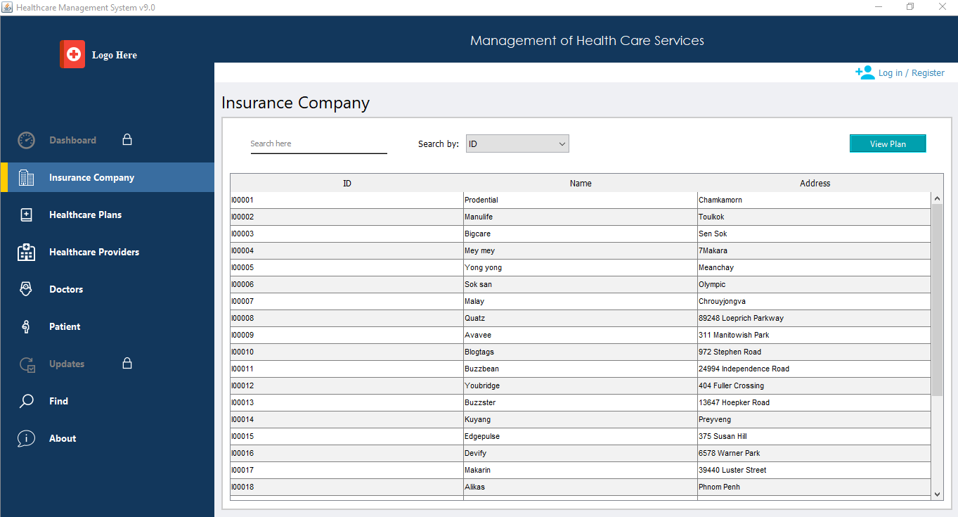

1. Double click an insurance

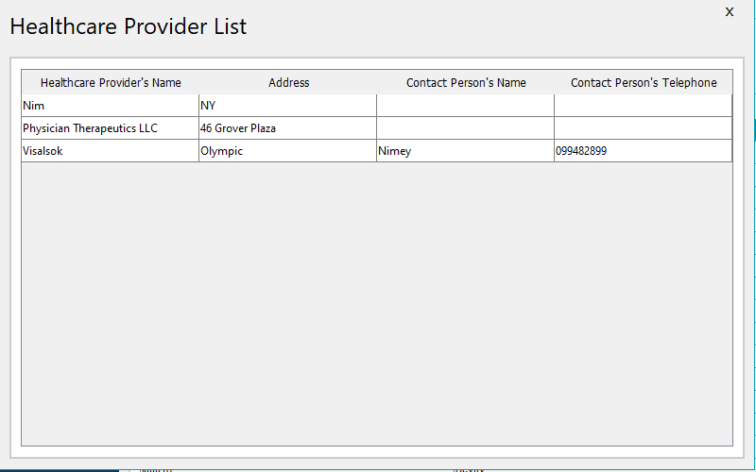

1. Select an insurance and click button View Plan

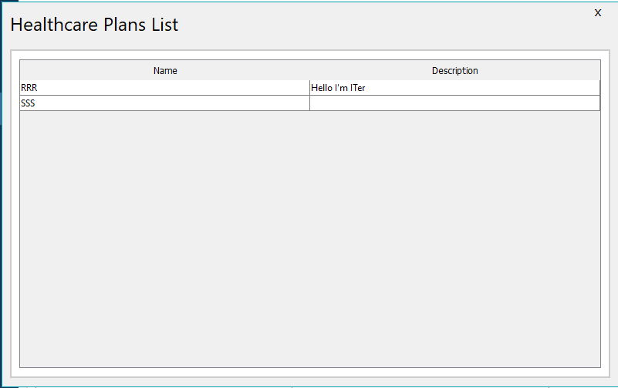

1. 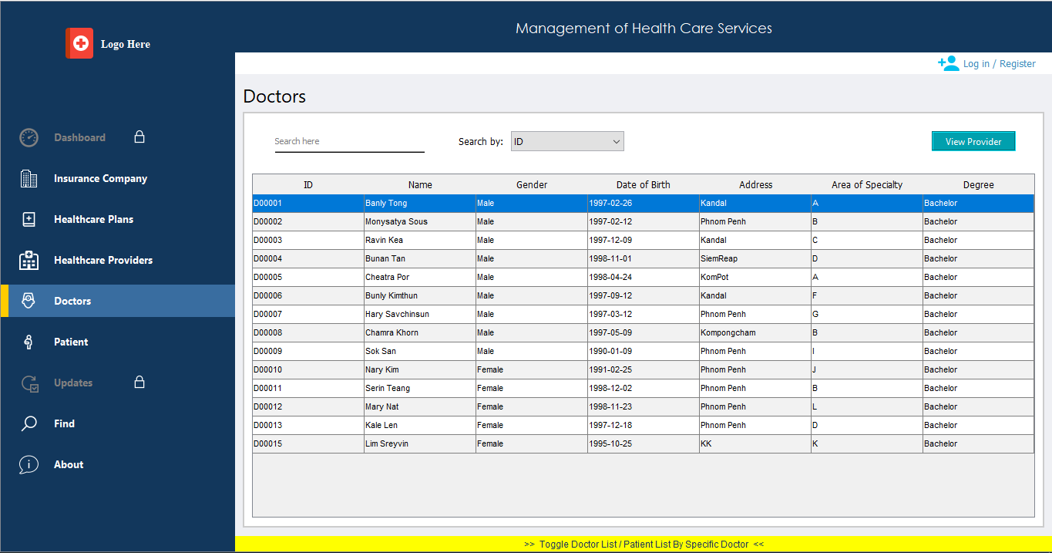Patient Tab click Toggle
2. Register and Login

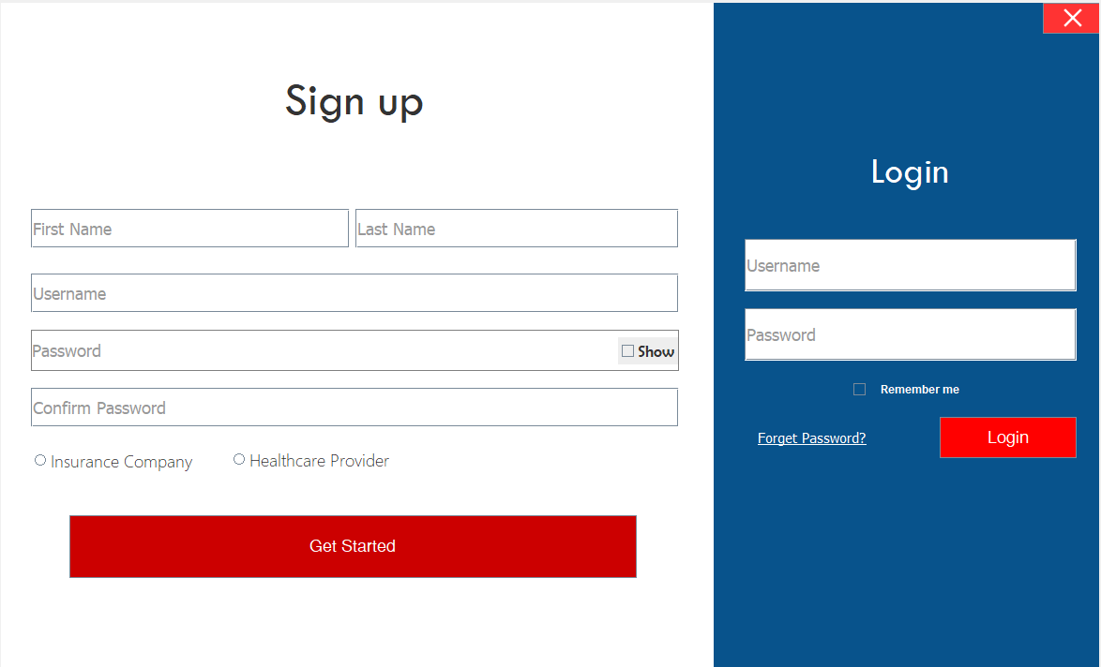

1. Dashboard

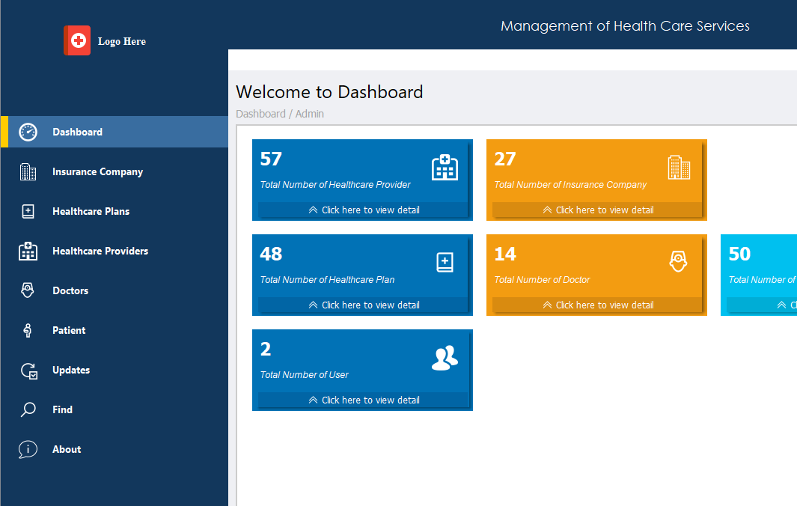

1. Update tab

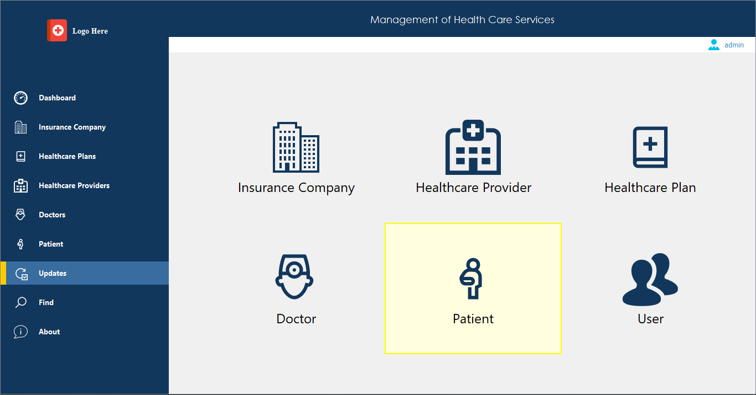

1. Update Function



1. Update Form

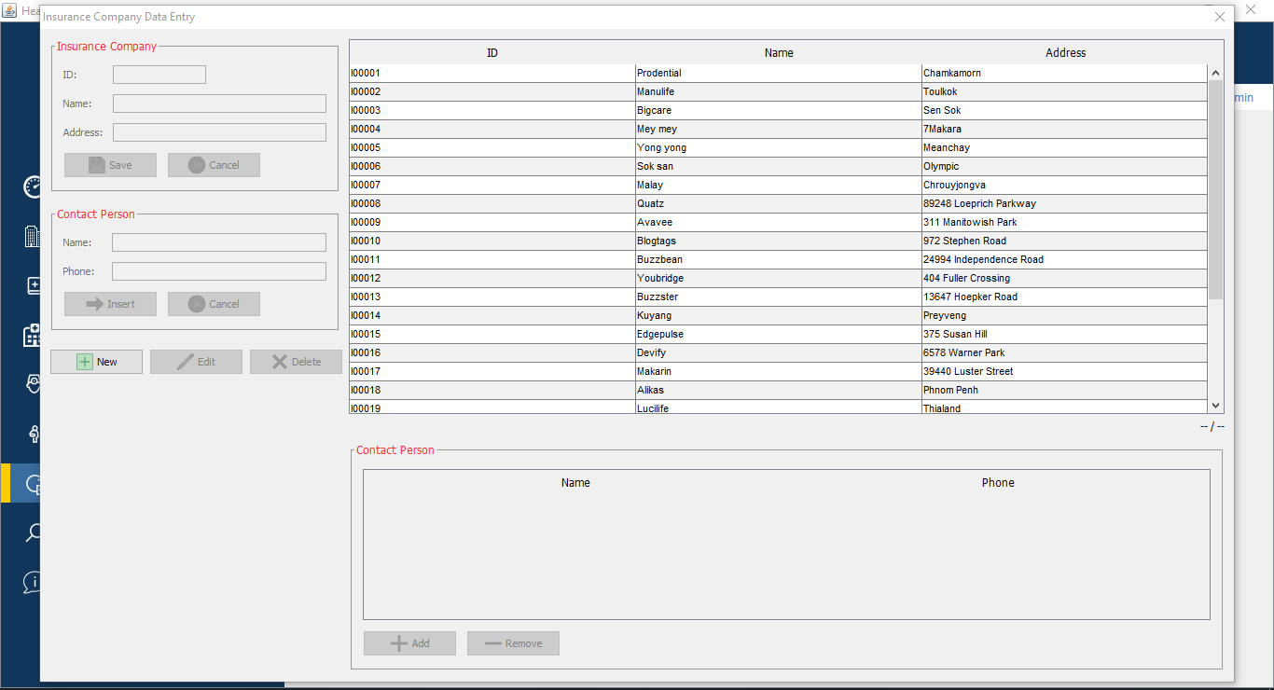

1. Find Function

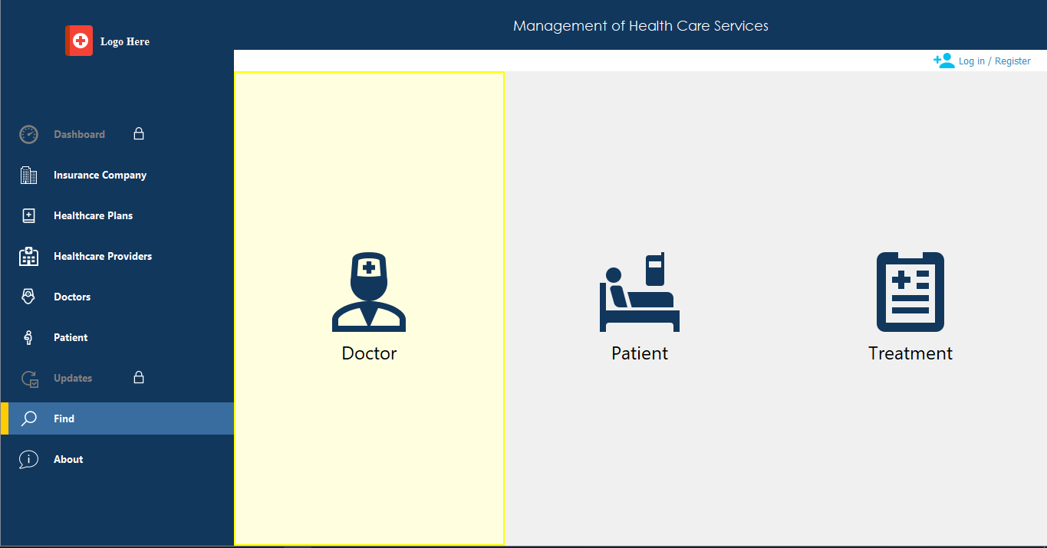

1. Find Form

